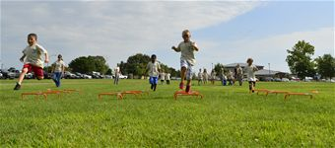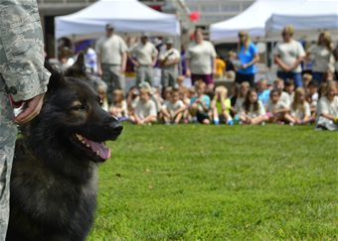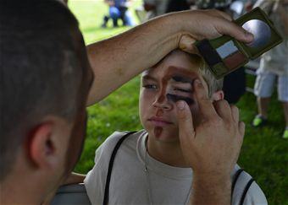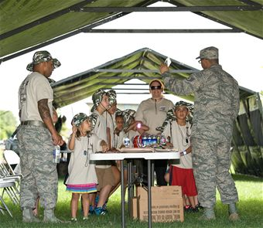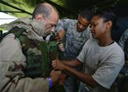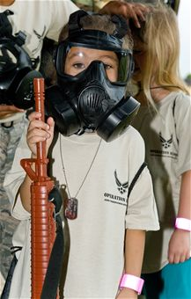

**REGISTER NOW!!!**

**REGISTER NOW!!!**

**AUGUST 26, 2015 10:00 – 3:00\***

***(Current mission times available at 11:00 and 1:00.******Event duration is approximately 1 hour, not including lunch and static displays.)***

**DAFB Youth Center**

**REGISTER/QUESTIONS: Sonya Dyer, School Liaison**

**sonya.dyer.1@us.af.mil OR (302) 677-6383**

**REGISTRATION DEADLINE AUGUST 12th**

**\*Held concurrently with KUDOS (Kids Understanding Deployment Operations)**

**(T**eachers **U**nderstanding **D**eployment **O**peration**S)\***

**Dover AFB presents**

**OPERATION TUDOS 2015**