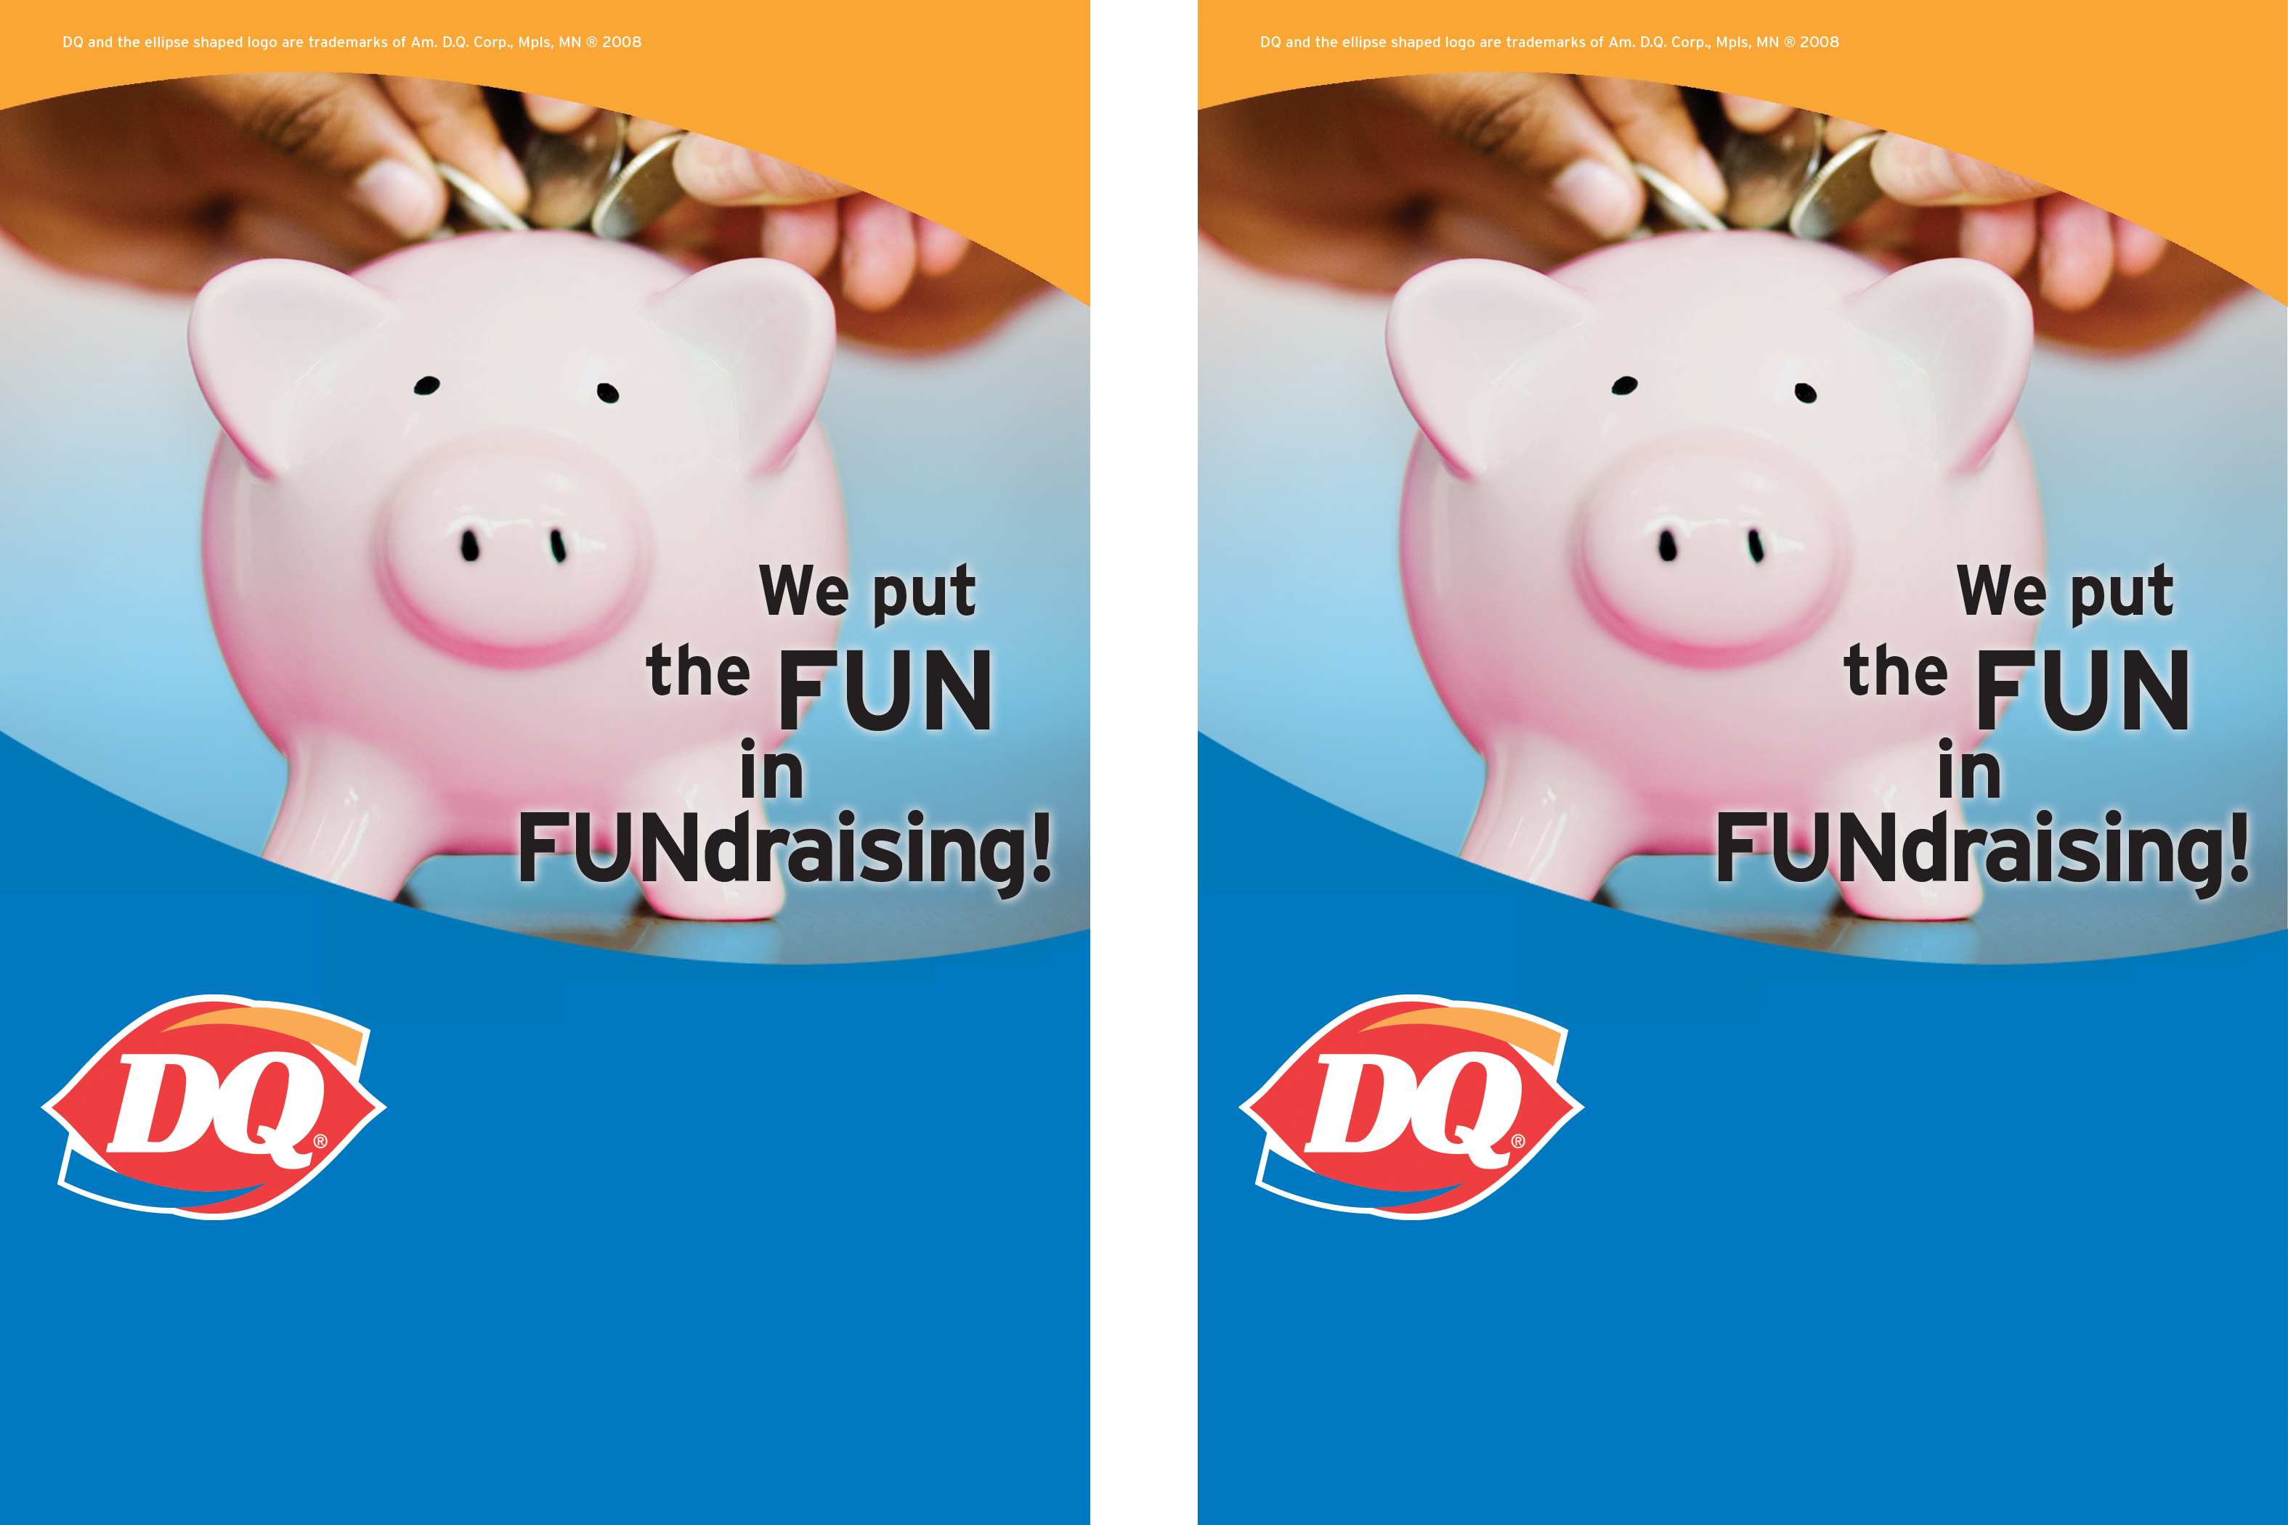
Place: Dairy Queen® of Newark, Chestnut Hill and Marrows Rd, Newark, DE 19713 302-737-1213

It’s easy to raise money for
your group with the
Dairy Queen of Newark.

Contact Donna or Dustin for more information
Place: Dairy Queen® of Newark, Chestnut Hill and Marrows Rd, Newark, DE 19713 302-737-1213

