

**<PTA NAME> Reflections®**

**<NAME OF AWARD>**

**Presented to**

**<STUDENT NAME>**

***<TITLE OF ARTWORK>***

2017-2018 National PTA Reflections® Program

***“Within Reach”***

INSERT SCHOOL/PTA LOGO HERE

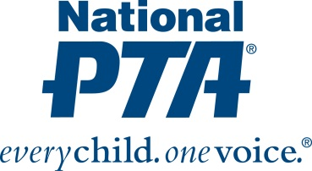

PTA Reflections Chair

PTA President